在Idea中使用Git在做合并分支时，发现某几个文件无法顺利完成合并。

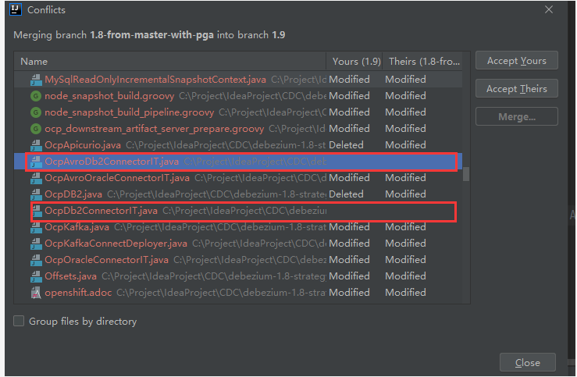

图中，类似这样的文件，则无法完成合并，也无法checkout到其他分支。

思路，需删除本地Git仓库的对应文件即可，暂时没有找到在Idea工具怎么删除Git仓库中的文件。这里使用命令行进行删除。

DELL@bad-pc-sr MINGW64 /c/Project/IdeaProject/CDC/debezium-1.8-strategy (1.9|MERGING)

$ git status -s

A .github/workflows/connect-rest-extension-workflow.yml

A ......

A debezium-testing/debezium-testing-system/src/test/java/io/debezium/testing/system/fixtures/databases/OcpOracle.java

DU debezium-testing/debezium-testing-system/src/test/java/io/debezium/testing/system/tests/db2/DockerRhelDB2ConnectorIT.java

M debezium-testing/debezium-testing-system/src/test/java/io/debezium/testing/system/tests/db2/DockerRhelDb2ConnectorIT.java

DU debezium-testing/debezium-testing-system/src/test/java/io/debezium/testing/system/tests/db2/OcpAvroDB2ConnectorIT.java

M debezium-testing/debezium-testing-system/src/test/java/io/debezium/testing/system/tests/db2/OcpAvroDb2ConnectorIT.java

DU debezium-testing/debezium-testing-system/src/test/java/io/debezium/testing/system/tests/db2/OcpDB2ConnectorIT.java

M debezium-testing/debezium-testing-system/src/test/java/io/debezium/testing/system/tests/db2/OcpDb2ConnectorIT.java

A debezium-testing/debezium-testing-system/src/test/java/io/debezium/testing/system/tests/oracle/OracleTestCases.java

?? debezium-testing/debezium-testing-system/src/test/java/io/debezium/testing/system/tests/db2/DockerRhelDB2ConnectorIT.java~1.8-from-master-with-pga

?? debezium-testing/debezium-testing-system/src/test/java/io/debezium/testing/system/tests/db2/OcpAvroDB2ConnectorIT.java~1.8-from-master-with-pga

?? debezium-testing/debezium-testing-system/src/test/java/io/debezium/testing/system/tests/db2/OcpDB2ConnectorIT.java~1.8-from-master-with-pga

DELL@bad-pc-sr MINGW64 /c/Project/IdeaProject/CDC/debezium-1.8-strategy (1.9|MERGING)

$ git rm debezium-testing/debezium-testing-system/src/test/java/io/debezium/testing/system/tests/db2/DockerRhelDB2ConnectorIT.java

rm 'debezium-testing/debezium-testing-system/src/test/java/io/debezium/testing/system/tests/db2/DockerRhelDB2ConnectorIT.java'

DELL@bad-pc-sr MINGW64 /c/Project/IdeaProject/CDC/debezium-1.8-strategy (1.9|MERGING)

$ git status -s

A .github/workflows/connect-rest-extension-workflow.yml

......

A debezium-testing/debezium-testing-system/src/test/java/io/debezium/testing/system/fixtures/databases/OcpOracle.java

D debezium-testing/debezium-testing-system/src/test/java/io/debezium/testing/system/tests/db2/DockerRhelDb2ConnectorIT.java

DU debezium-testing/debezium-testing-system/src/test/java/io/debezium/testing/system/tests/db2/OcpAvroDB2ConnectorIT.java

M debezium-testing/debezium-testing-system/src/test/java/io/debezium/testing/system/tests/db2/OcpAvroDb2ConnectorIT.java

DU debezium-testing/debezium-testing-system/src/test/java/io/debezium/testing/system/tests/db2/OcpDB2ConnectorIT.java

M debezium-testing/debezium-testing-system/src/test/java/io/debezium/testing/system/tests/db2/OcpDb2ConnectorIT.java

A debezium-testing/debezium-testing-system/src/test/java/io/debezium/testing/system/tests/oracle/OracleTestCases.java

?? debezium-testing/debezium-testing-system/src/test/java/io/debezium/testing/system/tests/db2/DockerRhelDB2ConnectorIT.java~1.8-from-master-with-pga

?? debezium-testing/debezium-testing-system/src/test/java/io/debezium/testing/system/tests/db2/OcpAvroDB2ConnectorIT.java~1.8-from-master-with-pga

?? debezium-testing/debezium-testing-system/src/test/java/io/debezium/testing/system/tests/db2/OcpDB2ConnectorIT.java~1.8-from-master-with-pga

DELL@bad-pc-sr MINGW64 /c/Project/IdeaProject/CDC/debezium-1.8-strategy (1.9|MERGING)

$ git rm debezium-testing/debezium-testing-system/src/test/java/io/debezium/testing/system/tests/db2/OcpAvroDB2ConnectorIT.java

rm 'debezium-testing/debezium-testing-system/src/test/java/io/debezium/testing/system/tests/db2/OcpAvroDB2ConnectorIT.java'

DELL@bad-pc-sr MINGW64 /c/Project/IdeaProject/CDC/debezium-1.8-strategy (1.9|MERGING)

$ git status -s

A .github/workflows/connect-rest-extension-workflow.yml

A ......

A debezium-testing/debezium-testing-system/src/test/java/io/debezium/testing/system/fixtures/databases/DockerOracle.java

A debezium-testing/debezium-testing-system/src/test/java/io/debezium/testing/system/fixtures/databases/OcpOracle.java

D debezium-testing/debezium-testing-system/src/test/java/io/debezium/testing/system/tests/db2/DockerRhelDb2ConnectorIT.java

D debezium-testing/debezium-testing-system/src/test/java/io/debezium/testing/system/tests/db2/OcpAvroDb2ConnectorIT.java

DU debezium-testing/debezium-testing-system/src/test/java/io/debezium/testing/system/tests/db2/OcpDB2ConnectorIT.java

M debezium-testing/debezium-testing-system/src/test/java/io/debezium/testing/system/tests/db2/OcpDb2ConnectorIT.java

A debezium-testing/debezium-testing-system/src/test/java/io/debezium/testing/system/tests/oracle/OracleTestCases.java

?? debezium-testing/debezium-testing-system/src/test/java/io/debezium/testing/system/tests/db2/DockerRhelDB2ConnectorIT.java~1.8-from-master-with-pga

?? debezium-testing/debezium-testing-system/src/test/java/io/debezium/testing/system/tests/db2/OcpAvroDB2ConnectorIT.java~1.8-from-master-with-pga

?? debezium-testing/debezium-testing-system/src/test/java/io/debezium/testing/system/tests/db2/OcpDB2ConnectorIT.java~1.8-from-master-with-pga

DELL@bad-pc-sr MINGW64 /c/Project/IdeaProject/CDC/debezium-1.8-strategy (1.9|MERGING)

$ git rm debezium-testing/debezium-testing-system/src/test/java/io/debezium/testing/system/tests/db2/OcpDB2ConnectorIT.java

rm 'debezium-testing/debezium-testing-system/src/test/java/io/debezium/testing/system/tests/db2/OcpDB2ConnectorIT.java'

DELL@bad-pc-sr MINGW64 /c/Project/IdeaProject/CDC/debezium-1.8-strategy (1.9|MERGING)

$ git status -s

A .github/workflows/connect-rest-extension-workflow.yml

A ......

A debezium-testing/debezium-testing-system/src/test/java/io/debezium/testing/system/fixtures/databases/DockerOracle.java

A debezium-testing/debezium-testing-system/src/test/java/io/debezium/testing/system/fixtures/databases/OcpOracle.java

D debezium-testing/debezium-testing-system/src/test/java/io/debezium/testing/system/tests/db2/DockerRhelDb2ConnectorIT.java

D debezium-testing/debezium-testing-system/src/test/java/io/debezium/testing/system/tests/db2/OcpAvroDb2ConnectorIT.java

D debezium-testing/debezium-testing-system/src/test/java/io/debezium/testing/system/tests/db2/OcpDb2ConnectorIT.java

A debezium-testing/debezium-testing-system/src/test/java/io/debezium/testing/system/tests/oracle/OracleTestCases.java

?? debezium-testing/debezium-testing-system/src/test/java/io/debezium/testing/system/tests/db2/DockerRhelDB2ConnectorIT.java~1.8-from-master-with-pga

?? debezium-testing/debezium-testing-system/src/test/java/io/debezium/testing/system/tests/db2/OcpAvroDB2ConnectorIT.java~1.8-from-master-with-pga

?? debezium-testing/debezium-testing-system/src/test/java/io/debezium/testing/system/tests/db2/OcpDB2ConnectorIT.java~1.8-from-master-with-pga

DELL@bad-pc-sr MINGW64 /c/Project/IdeaProject/CDC/debezium-1.8-strategy (1.9|MERGING)

$ git add .

DELL@bad-pc-sr MINGW64 /c/Project/IdeaProject/CDC/debezium-1.8-strategy (1.9|MERGING)

$ git commit -am 'commit'

[1.9 c33b3344a] commit

DELL@bad-pc-sr MINGW64 /c/Project/IdeaProject/CDC/debezium-1.8-strategy (1.9)

$ git pull

Already up to date.